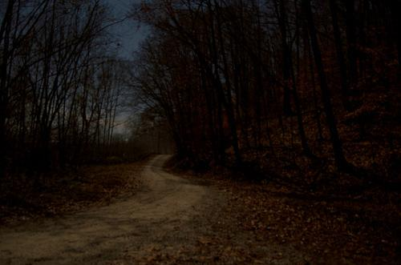

Left 4 Dead: Cabin Fever –

Lvl3 Nature Trail

  - Version 0.0
Designer: | Nicholas Carter
Document Date: | 9/12/19
Intended Level Delivery Date: | 12/13/19

Document Revisions Table
Version | Description | Requestor | Date
1.0 | Initial Document | Professor Skinner | 9/16/19
2.0 | Revisions | Professor Skinner | 9/23/19
3.0 | Final Revisions | Professor Skinner | 9/28/19

Table of Contents
Table of Contents 2
Table of Figures 3
Level Information 4
Quick Summary 4
Setting 4
Level Map(s) 5
Nature Trails Map 5
Objective(s) 7
Hook(s)/Gameplay Highlights 7
Campaign 7
Context 7
Backstory 7
Aftermath 8
Development Schedule 9
Key Theme References 10
Visual Theme: Contact Sheet 1 - Concept 10
Visual Theme: Contact Sheet 2 - Lighting 11
11
Visual Theme: Contact Sheet 3 – Trail Roundabout 12
Visual Theme: Contact Sheet 4 – Public Restroom 13
13
Visual Theme: Contact Sheet 4 – Welcome Center 14
Visual Theme: Contact Sheet 4 – Ending Safe Room 15
Requirements 16
Appendix A: Quest Summary 16
Main Quest 16
References 17

Table of Figures

Figure 1: Nature Trail Digital Map (Top-Down) 5
Figure 2: Nature Trail Welcome Center Map (Top-Down) 8
Figure 3: Nature Trail Restroom Map (Top-Down) 8
Figure 4: Contact Sheet for Visual Theme 1: Concept 9
Figure 5: Contact Sheet for Visual Theme 2: Lighting 10
Figure 6: Contact Sheet for Visual Them: Trail Roundabout 10
Figure 7: Contact Sheet for Visual Theme: Public Restroom 13
Figure 8: Contact Sheet for Visual Theme: Welcome Center 14
Figure 9: Contact Sheet for Visual Theme: Ending Safe Room 15

Level Design Document

Level Information

Quick Summary
Level 3 of the multiplayer custom campaign, “Cabin Fever” in Left 4 Dead begins on the “Nature Trail” just outside of the “Neighborhood” that the player must progress through to breach the Cabin in the Wood Finale. This level is about 5-6 minutes of playtime and it takes place in the evening along the dark, dense, and foggy Nature Trail that veers off into the woods. The player will navigate through thick tree lines, tight pathways, and ditches that transition into the deep woods. The survivors must travel to the nearby utilities maintenance closet inside the Nature Trail to breach the deep woods that leads them into the Cabin in the Woods.
Help the survivors navigate through the Nature Trail to make their way to the “Cabin in the Woods” finale to evacuate the Rural county
The players will navigate through the Oak Pines Nature Trail which is about 2 miles long with mostly flat terrain and branching pathways that lead walkers back onto their main pathways. The trail is narrow with closed foggy dense corridors that can be creepy for the player(s).

Setting
The Nature Trail is located in the rural county just on the backside of a Neighborhood. It’s in the evening in a dark barely lit trail. Electricity isn’t present and much of the inhabited areas, like the parking lots just before the trail have cars with headlights to light the area. The trails have elevated ground above them and are burrowed behind the trails thick tree lines.

Level Map(s)

Nature Trails Map
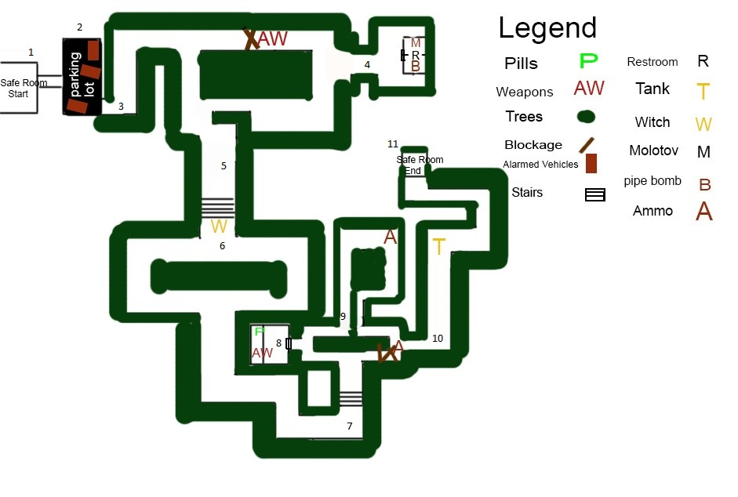
Overview
Roundabout
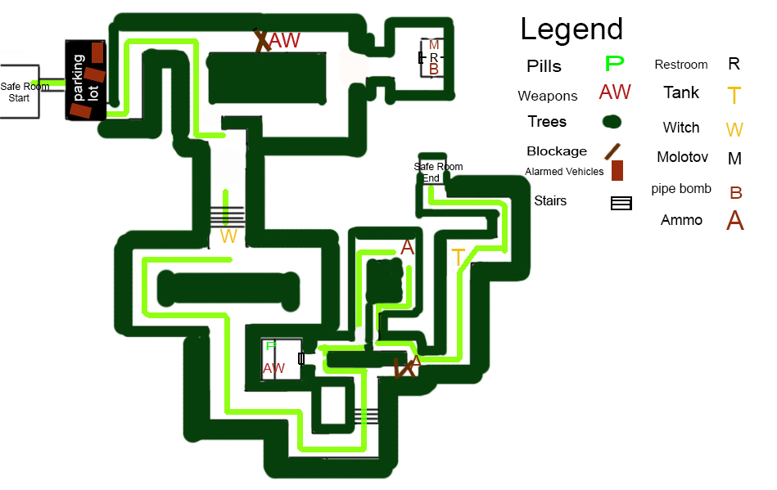
Roundabout
Critical Path Map
Figure 1: Nature Trail Digital Map Draft (Top-Down)

Map Label | Event Description | Detail Information | Approx. Difficulty (1-10) | Approx. Time | Wow?
1 | Players exits the saferoom | The safe room will have light weapons such as the SMG and pump shotgun. of the back of a house where they'll notice a broken down fence, the player must explore the broken path up ahead | 0 | 0:00 | N
2 | Players will travel through the parking lot. Just up ahead is the Nature trail entrance | The parking lot will have it’s first collection of infected the player should see within the parking lot, within trees. The infected will be surrounded by a few alarmed vehicles. | 2 | 0:15 | N
3 | The player will enter the Nature Trail. | The trail begins here, use long line of sight views and closed combat weapons to your advantage for the narrow pathways. | 4 | 0:35 | N
4 | The player will discover the Public Restroom | This restroom will either spawn Molotov’s, pills and pipe bombs for the player to grab. There is also a rescue closet there as well. | 5 | 0:50 | N

Map Label | Event Description | Detail Information | Approx. Difficulty (1-10) | Approx. Time | Wow?
5 | The player will enter the stairs which is a bit of a wider corridor | The stairs are slightly wider than the narrow paths before, players can use this wide view to sweep up the trail before them that splits. | 5 | 1:50 | N
6 | Survivors will encounter another branching trail. | Infected will be spawned and available from both pathways and no path will be blocked off like the previous. | 7 | 3:05 | N
7 | After passing through the branching path players will make their ways back along the critical path and another set of stairs. | The stairs brings the player to yet another branching trail that is blocked off by trees. Be sure to check the interiors ahead or blocked areas for supplies. | 6 | 5:30 | N
8 | Player's will discover the Nature Trails Welcome Center | This space will have supplies for ammo, medicine and potentially advanced weapons. | 8 | 5:15 | N
9 | Beyond is an elevated Roundabout that the player must travel through | This space should be used to fight off a horde with it’s wide view and elevation for the player to anticipate incoming infected. This is the highest elevation on the level. | 5 | 5:35 | N
10 | After the roundabout the player proceeds around the corner to what is the last wooded corridor before the safe room up ahead. | After making their way past the roundabout, a Tank has potential for spawning. This should push the player back to the roundabout and branching paths ahead. If you can, gain elevation on the Tank to take him out. | 7 | 6:05 | Y
11 | The survivors will approach the Safe Room. | After defeating the Tank, the player should have the right of way to the safe room if they’re not too busy fighting off common infected amongst the trees. The safe room is just a utilities cabin along the trail path. | 2 | 6:55 | N

Objective(s)
- Level 3 objective: Pass through the Nature Trail and make your way to the safe room within the Welcome Center to travel further into the deep woods to the Cabin for rescue.

Hook(s)/Gameplay Highlights
- Player will navigate through tight pathways with thick tree lines
- Players must stay together and proceed around corners of the nature trail cautiously to steer clear of special infected.
- The Nature Trail will have inaccessible elevated terrain beyond the thick tree lines that special infected can spawn and attack the player from
- Potential for at least one Tank and or witch encounter along the critical path.

Campaign

Context
Cabin Fever is a custom Left 4 Dead standalone campaign. Players play as the traditional four survivors (Bill, Zoey, Francis, and Louis) as usual, however the scenario time is that they are in a rural town and must escape by any means necessary to the Cabin in the Woods nearby hoping they can find
rescue away from the dense city population.

Backstory
The four players have just found each other as the last few survivors of the city and are stranded on one
of the town’s rooftops. Together they agree that they must get out of the town and head for the rural less populated forest area as quickly as possible. Their hopes are to find rescue once they escape the town into the rural area, but first things first: get the hell out of TOWN!

The Nature Trail that the players must travel is called the Oak Pine Trail. It’s about a couple mile longs with branching pathways, a restroom rest stop and an Welcoming Center as well. The Nature Trail is breach-able through the parking lot.

Aftermath
After the players travel through the Nature Park reserve and breach the Welcome Center streets to make their way to the evac location at the Cabin in the woods.
If successful, the survivors will have victoriously completed the campaign and live to tell the tale. As with
all Left 4 Dead campaigns, this campaign is standalone and does not reference other Left 4 Dead
campaigns. As this is the finale for our campaign there are no aftermath effects.

Failure: If the players fail, they will return back to the nearest Safe Room to restart the level.

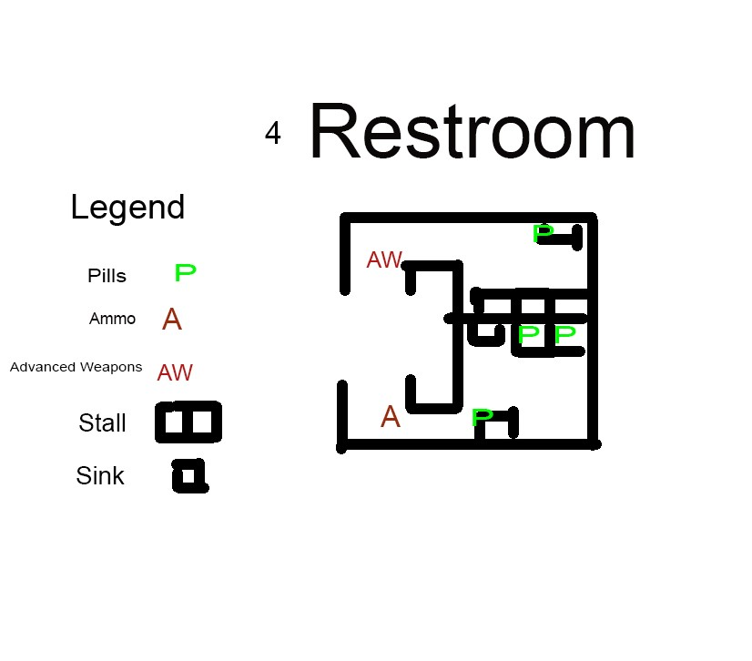
Figure 2: Nature Trail Digital Map Restroom (Top-Down)

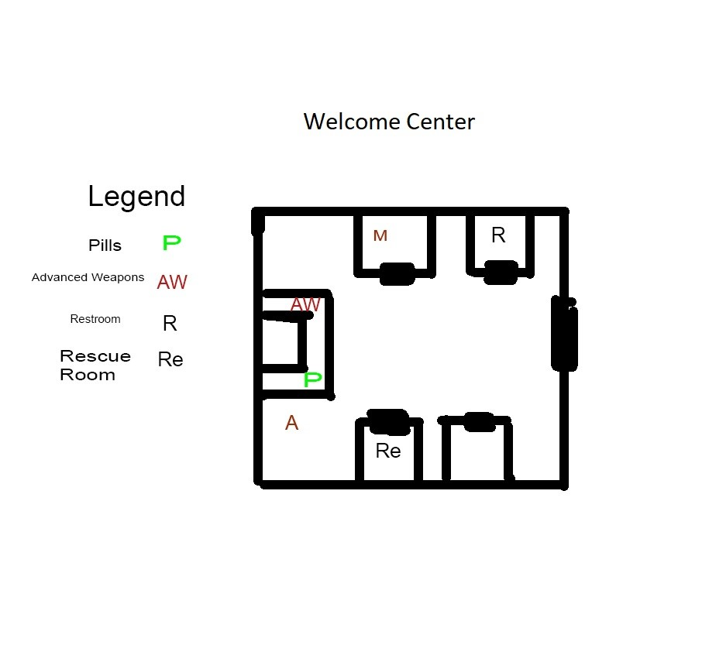
Figure 3: Nature Trail Digital Map Welcome Center (Top-Down)

Development Schedule
Milestone | Date
LDD | 9/23
Whitebox | 10/17
Gameplay | 11/4
Aesthetics | 11/25
RTM | 12/13

Key Theme References

Visual Theme: Contact Sheet 1 - Concept

Figure 4: Contact Sheet for Visual Theme 1 : Nature Trails Park Aesthetic

Visual Theme: Contact Sheet 2 - Lighting

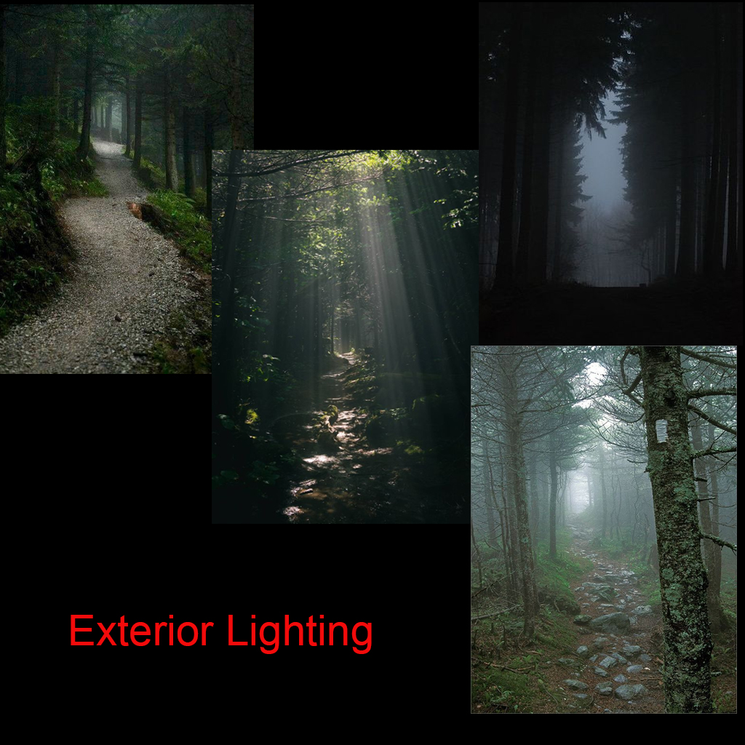
Foggy Atmosphere
Figure 5: Contact Sheet for Visual Theme 2: Nature Trails Park Lighting

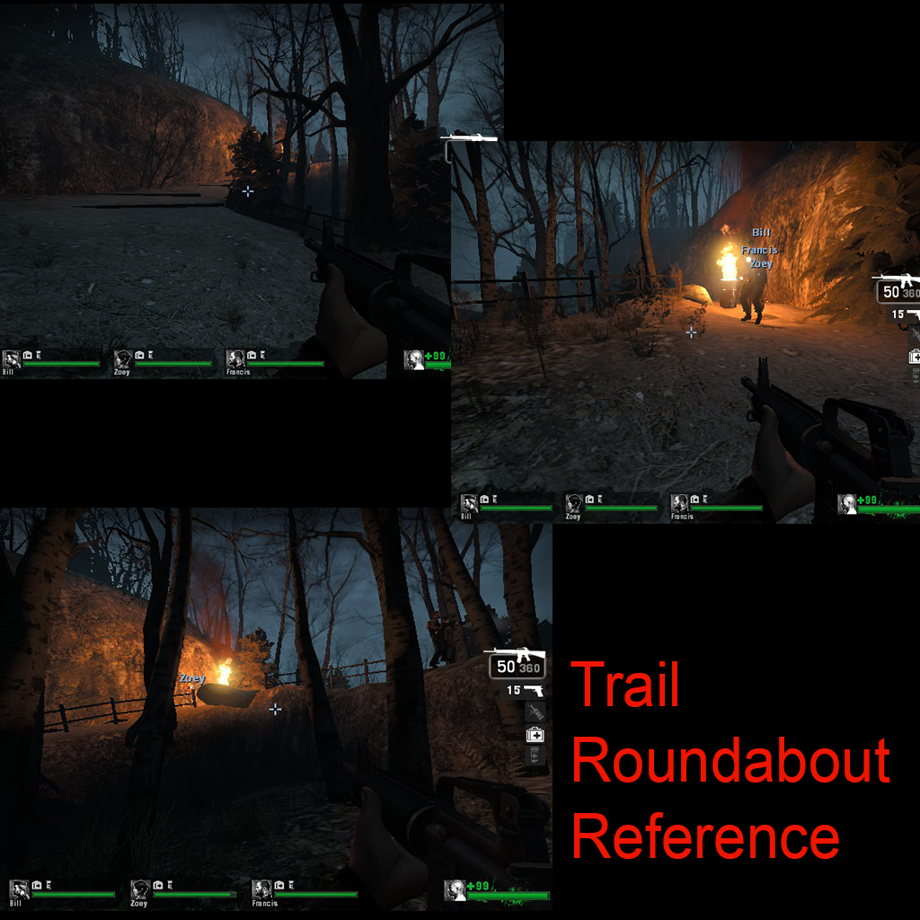
Visual Theme: Contact Sheet 3 – Trail Roundabout

Figure 6: Contact Sheet for Visual Theme: Nature Trails Park Roundabout

Visual Theme: Contact Sheet 4 – Public Restroom

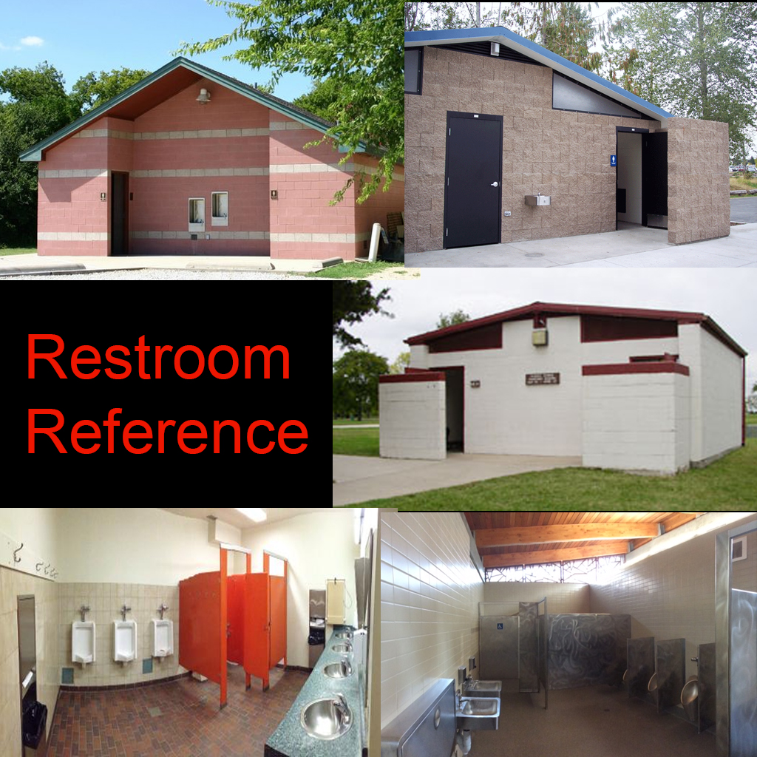
Exterior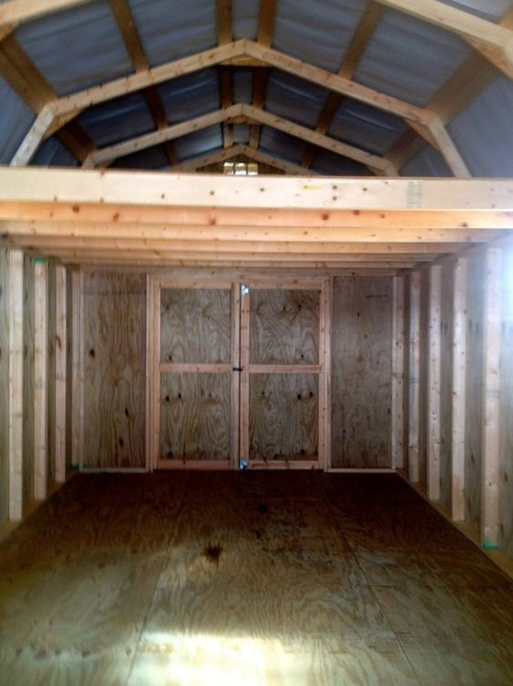 Utilitiy Shed Safe Room
Utilitiy Shed Safe Room
ior
Interior

Figure 7: Contact Sheet for Visual Theme: Nature Trails Public Restroom

Visual Theme: Contact Sheet 4 – Welcome Center
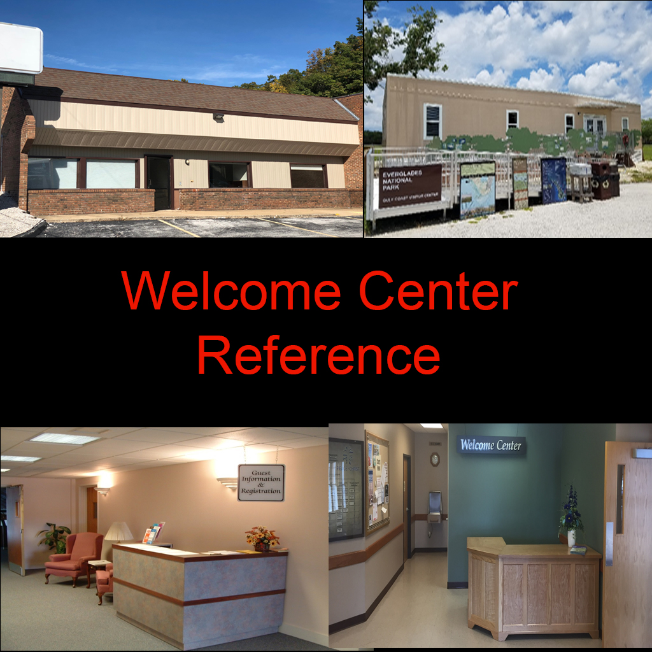
Interior
Exterior Utilitiy Shed Safe Room
Utilitiy Shed Safe Room
ior
Figure 8: Contact Sheet for Visual Theme: Nature Trails Welcome Center

Visual Theme: Contact Sheet 4 – Ending Safe Room

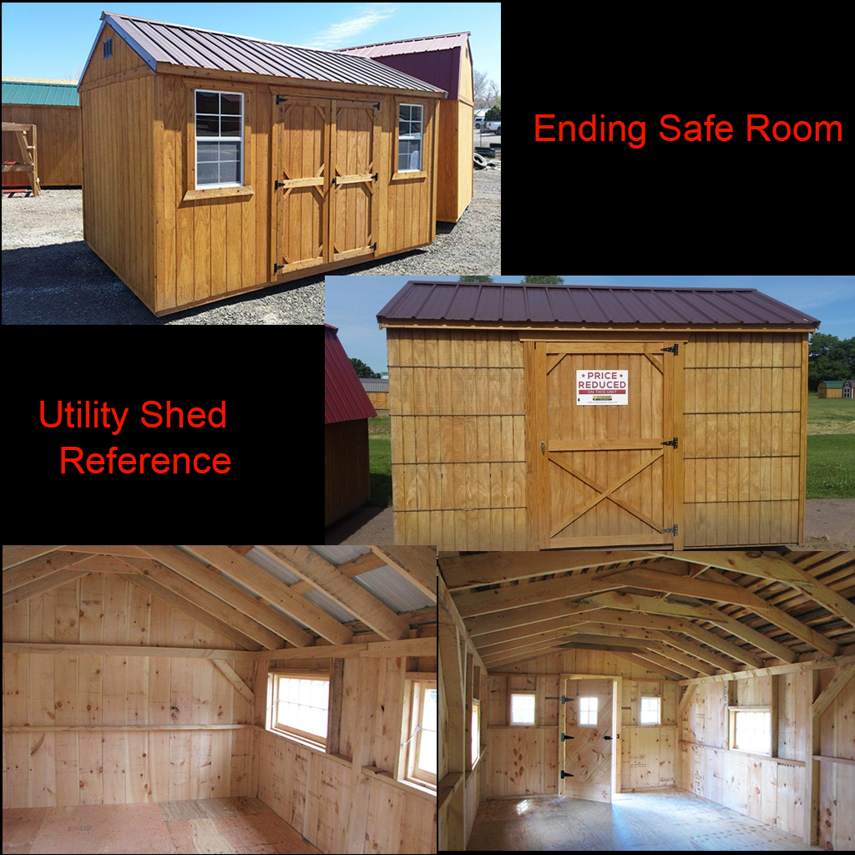
Interior
Exterior Utilitiy Shed Safe Room
Utilitiy Shed Safe Room
ior
Figure 9: Contact Sheet for Visual Theme: Ending Safe Room

Requirements
Map Label | Description | Type | Priority
1 | BSP Blockout Construction | LD | High
2 | Nav Mesh | LD | High
3 | AI Director | LD | High
4 | Set Dressing | LD | High
5 | Boss Zombie Spawns | LD | Medium
6 | Rescue Closet | LD | Medium
7 | Terrain Patching | LD | Low
8 | Lighting | LD | Low
9 | Item Placement | LD | Medium

Appendix A: Quest Summary

Main Quest
- Players exits the saferoom of the back of a house where they'll notice a broken-down fence, the player must explore the broken path up ahead.
- The survivors stumble across a large deserted parking lot with some infected and alarmed vehicles. just up ahead is the Nature trail entrance.
- The Nature trail entrance is narrow and very dark with branching pathways that eventually lead the player back along the critical path. Proceed carefully around corners and long corridor sight lines.
- The player may stumble across the bathroom that will have pills and weapons potentially available.
- The players will enter the stairs which is a bit of a wider corridor.
- Survivors will encounter another branching trail that may have supplies available
- After passing through the branching path players will make there ways back along the critical path and another set of stairs just beyond a corner ahead.
- Player's will approach what appears to be a small welcoming center that's been abandoned with supplies inside.
- Beyond is an elevated roundabout that the player must go around to breach the highest altitude of the nature trail. This spot is helpful for a due to it's opening space elevation.
- After the roundabout the player proceeds around the corner to what is the last wooded corridor before the safe room up ahead. it's very narrow and has potential for a tank to spawn just before the safe room
- The survivors will approach the safe room which is just a utilities cabin of the nature trail.

References
- https://www.pinterest.com/pin/563020390912122103/?nic=1 https://www.pinterest.com/pin/111956740715253344/?lp=true
- https://www.pinterest.com/nrcarter95/nature-trail/
- https://left4dead.fandom.com/wiki/The_Town
- https://www.google.com/search?q=nature+trail+park&rlz=1C1CHBF_enUS810US810&sxsrf=ACYBGNT_dYVTGHNY1EoWdJN0V-0T35wcDA:1569271831213&source=lnms&tbm=isch&sa=X&ved=0ahUKEwi9sLiQ6efkAhUNOK0KHXuiCIgQ_AUIEygB&biw=1280&bih=646#imgrc=P0wcgQ4Axjbq-M:
- https://left4dead.fandom.com/wiki/The_Town?file=Demo_l4d_smalltown04_mainstreet.jpg\
- https://www.google.com/search?q=nature+trail+layout&rlz=1C1CHBF_enUS810US810&sxsrf=ACYBGNSf_X3eaFkOnEhwciH-nLiMjLV53Q:1569271890721&source=lnms&tbm=isch&sa=X&ved=0ahUKEwityOis6efkAhUCEqwKHdtdBboQ_AUIEygB&biw=1280&bih=646&dpr=1.5#imgrc=yOy6KOQA-1RskM:
- file:///C:/Users/Nicholas%20Carter/Desktop/LD3%20Semester%204/reference%20images/shed_concept.jpg
- https://www.google.com/search?q=park+restroom&rlz=1C1CHBF_enUS810US810&sxsrf=ACYBGNSII1fy7aDDu1tc3bnrs9Tf9kX7Pg:1569766251785&source=lnms&tbm=isch&sa=X&ved=0ahUKEwjAo8X-mvbkAhUPKa0KHV7GC3EQ_AUIEigB&biw=1280&bih=613#imgrc=jn6QVwMeOewl2M:
- https://www.google.com/search?biw=1280&bih=613&tbm=isch&sxsrf=ACYBGNSy-A33sXMdww0WavxbmU_QJfQ5Kw%3A1569767318880&sa=1&ei=lr-QXZ6qNYHYsQW2s7ToDw&q=restroom+exterior&oq=restroom+exterior&gs_l=img.3..0.13018.16241..16368...0.0..0.144.1430.17j1......0....1..gws-wiz-img.......35i39j0i30j0i5i30j0i8i30j0i67j0i24.ViJNo4ma-jk&ved=0ahUKEwieza_7nvbkAhUBbKwKHbYZDf0Q4dUDCAc&uact=5#imgrc=Ic7bFrTCpTrqIM:
- https://www.google.com/search?biw=1280&bih=613&tbm=isch&sxsrf=ACYBGNSifrOVilnJBVWrFHRELzc2nNXNEg%3A1569768471286&sa=1&ei=F8SQXdH6EIv2tAW4tYjYDQ&q=sma+llwelcome+center+interior&oq=sma+llwelcome+center+interior&gs_l=img.3...8768.9360..9556...0.0..0.83.438.6......0....1..gws-wiz-img.0uKzhZRToJU&ved=0ahUKEwiR4vCgo_bkAhULO60KHbgaAtsQ4dUDCAc&uact=5#imgrc=iqzSN9JybVDmuM:
- https://www.google.com/search?biw=1280&bih=613&tbm=isch&sxsrf=ACYBGNSc1izD92lHYP7H8Gt4JIHA5x-9YA%3A1569768684581&sa=1&ei=7MSQXYmFI4nEsAXm5p14&q=utlitity+shed&oq=utlitity+shed&gs_l=img.3...525035.526810..527370...0.0..0.219.1394.10j2j1......0....1..gws-wiz-img.......35i39j0j0i67j0i10j0i10i24.D9ikrlKfdh8&ved=0ahUKEwiJq8uGpPbkAhUJIqwKHWZzBw8Q4dUDCAc&uact=5#imgrc=nGpQiOkGI9UHMM:

