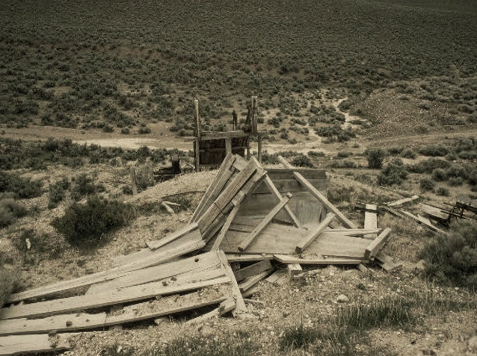

Fallout 4: New Broken Hills
  - Version 1.0
Designer: | Nicholas Carter
Document Date: | 3/5/19
Intended Level Delivery Date: | 5/6/19

Document Revisions Table
Version | Description | Requestor | Date
1.0 | Initial Document | Professor Skinner | 3/5/19

Table of Contents
Table of Contents 2
Table of Figures 3
Level Information 4
Quick Summary 4
Level Map(s) 4
Commonwealth Map 4
Paladin Cohen’s Bunker (Receive Quest) 5
New Broken Hills 6
New Broken Hills (Mutant’s Layer) 7
Paladin Cohen’s Bunker (Quest End) 9
Objective(s) 10
Hook(s)/Gameplay Highlights 10
Main Gameplay Mechanics 10
Campaign 10
Context 10
Backstory 10
Aftermath 11
Development Schedule 11
Key Theme References 12
Visual Theme 1 for Paladin Cohen’s Bunker 12
Visual Theme 2 for New Broken Hills 13
Visual Theme 3 (replace with meaningful name of theme)> 14
14
Requirements 15
Appendix A: Quest Summary 16
Main Quest 16
References 17

Table of Figures

Figure 1: <meaningful name of map 1> 3
Figure 2: <meaningful name of map 2> 3
Figure 3: Contact Sheet for Visual Theme 1 [#] 3
Figure 4: Contact Sheet for Visual Theme 2 [#] 3

Level Design Document

Level Information

Quick Summary
New Broken Hills is a story based single player branching fetch quest mod on Fallout 4. In this quest, during the daytime the player will discover Paladin Cohen, a member of the Brotherhood within the Commonwealth at the Wicked Shipping Fleet Lookout. After helping Cohen fight off ghouls, he asks that you assist him in wiping out supermutants and recovering nuclear materials from them for the Brotherhood of Steel. The player is sent to investigate a bunker nearby the Robotics Disposal Ground to seek information from various NPC’s and potentially take out the supermutants and “free” the humans of captivity, according to Paladin Cohen. This quest is a branching quest and allows the player to make two decisions to aid the Brotherhood with their endeavours, or to “fake it” and side with the opposition at the settlement. The player will be engaged in close to mid-ranged combat against Rad roaches with a level 8 character. After gathering information from the inhabitants, the player will encounter a Super-mutant guarding nuclear material that the player will either have to fight to take from him, or agree to inform the settlement and Supermutants of the Brotherhood’s awareness of their existence.

Level Map(s)

Commonwealth Map
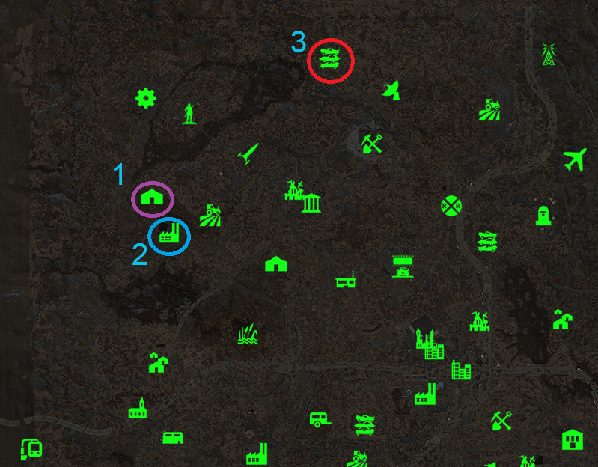
9

Figure 1: Location of Quest Start, Quest Retrieval and Quest Location (Commonwealth)

Paladin Cohen’s Bunker (Receive Quest)
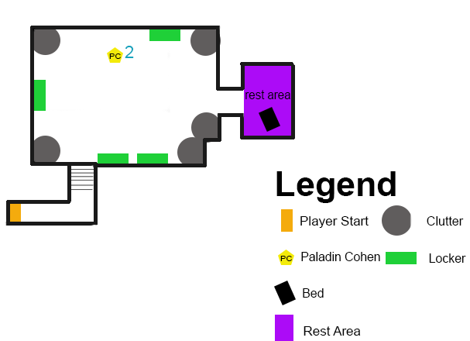
Figure 2: Paladin Cohen’s Bunker
Map Label | Event Description | Detail Information | Approx. Difficulty (1-10) | Approx. Time | Wow?
1 | Player Start | The player will start on Ranger Ranch and will be facing directly where he/she will need to travel to receive the main quest. Gunshots will lead the player to the designated location. | 1 | 0:00 | N
2 | Player Meets NPC | The Player will discover Brotherhood member, Paladin Cohen fighting off 3 Ghouls as he is trying to secure a bunker at this location. The player will help Cohen fight off the ghouls and engage in a conversation afterwards where the player will receive the quest from Cohen to visit a underground layer where humans are supposedly being held captive by Super-mutants. | 3 | 0:35 | N

New Broken Hills
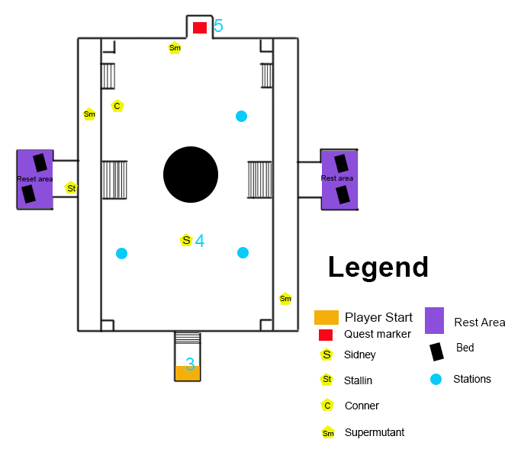
Figure 3: New Broken Hills
Map Label | Event Description | Detail Information | Approx. Difficulty (1-10) | Approx. Time | Wow?
3 | Player Receives Quest | After receiving the quest, the player will travel to the nearby bunker entrance at the Robotics Disposal Ground to a settlement where the player will enter to carry out the quest. | 3 | 4:15 | N
4 | Player speaks to the leader of New Broken Hills | Upon entering the bunker, the player will greet a woman by the name of Sidney Graham. She welcomes you to the settlement to which she informs you of their coexistence with Supermutants. The player can choose to kill all the Supermutant’s and proceed toward the underground layer if they choose to carry out Paladin’s request. | 0-5 | 4:25 | Y
5 | Player travels to Nuclear materials | After exploring the settlement, the location of nuclear materials become revealed in the bunker entrance just north of the settlement. It’s guarded by a Supermutant named Grem that the player can speak to. | 0-5 | 8:40 | N

New Broken Hills (Mutant’s Layer)
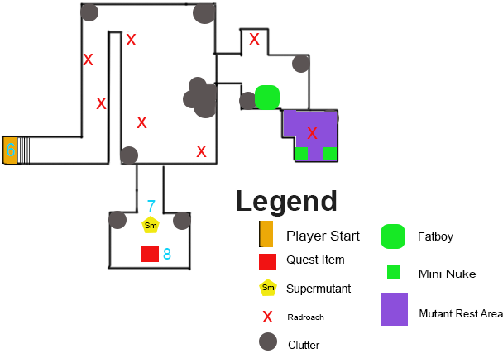
Figure 4: New Broken Hills Mutant Layer
Map Label | Event Description | Detail Information | Approx. Difficulty (1-10) | Approx. Time | Wow?
6 | Player discovers the Mutant layer | After entering the underground mutant’s layer, the player will fight past seven radroaches. The Supermutant’s resting post has a couple of mini nukes and a fatboy the player can grab to fight off the combat the player will have the choice of making in the future. | 3 | 8:45 | Y
7 | Player encounters the guardian Supermutant | In the dead-end of the south side of the cell, the player will encounter a Supermutant by the name of Grool. He apologizes for the mess and ask the player what they need. In this stage the player can choose to tell Grool to move out of the way in an attempt to take the nuclear materials and engage in combat. If the player hasn’t already fought the settlers in the upper layer, he will have to on the way out as a result of killing Grool. If Grem is still alive in the attack of Grool he runs and informs Sidney and all the Settlers of the players actions. Also, the player can inform Grool of the Brotherhood of Steel’s awareness of the settlement, and suggest everyone relocate. Grool will offer to give the player a fake nuclear canister to return to Cohen to “satisfy” the Brotherhood’ technological request at the least in an attempt to fool the Paladin. | 0-6 | 10:20
8 | Player retrieves Quest Item | If the player kills the Super mutant he will grab the Nuclear Material canisters and proceed to the exit. If the player choose not to kill Grool, he will receive fake nuclear canisters to return to the Paladin as mentioned above. | 0-6 | 11:14
9 | Player Returns to Paladin Cohen | The player will return to Paladin Cohen’s to give him the nuclear materials. You can inform Cohen if you’ve eliminated the Supermutants or lie if you chose to let them live, either way the Paladin will believe you. The player can give the Paladin the canisters (fake or real) and receive a reward of 500 bottlecaps to complete the quest, or the player can keep the materials and engage in combat with Paladin Cohen. Ultimately giving the Paladin nothing results in quest failure. | 2-7 | 14:55

Paladin Cohen’s Bunker (Quest End)
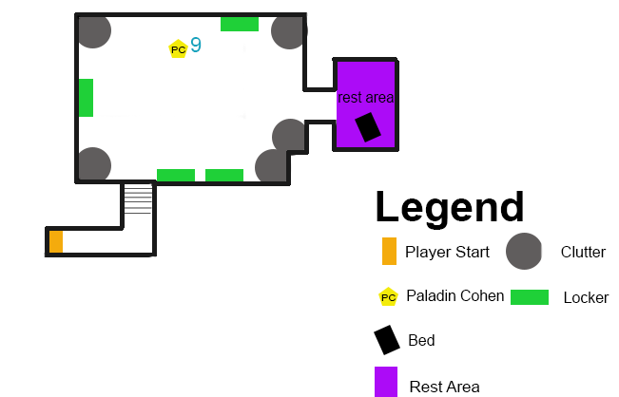
Figure 5: New Broken Hills Mutant Layer

Objective(s)
- Deal with the Supermutants and retrieve the nuclear materials for Paladin Cohen
  - Discover and investigate the underground layer Cohen informed you of
  - Reveal the location of the Nuclear Materials Cohen seeks
  - Confront the Supermutant guarding the nuclear materials
    - Collect Fetch Item
- Return the Nuclear Materials and inform Paladin Cohen of the termination of Supermutants.
  - Collect Reward

Hook(s)/Gameplay Highlights
- Character development with driven motives and backstories for context
  - i.e Paladin Cohen is a member of the Brotherhood who seeks technology that the New Broken Hills settlement has, however Cohen is unaware that the settlement (inhabited with humans and Supermutants) live amongst each other in peace and solitude.
  - Nuanced conversations/dialogue
  - Meaningful dialogue from NPC’s on backstory of the settlement.
  - Morally grey player choices
    - Player is faced with the vital choice of siding with the Brotherhood and preserving nuclear materials, or destroying a settlement and robbing them of their valuable resources.

Main Gameplay Mechanics
The player will use dialogue to obtain more information on the Brotherhood’s cause, and the purpose of New Broken Hills. Player will also engage in one combat encounter located inside the layer of New Broken Hills with Radroaches and an optional encounter with a Super-mutant within the underground bunker depending on the players quest branch decision.

Campaign

Context
New Broken Hills takes place within Fallout 4’s main storyline in the Commonwealth with the player using the main character, The Sole Survivor. The quests will be taking place with a level 7 character.

Backstory
New Broken Hills is a underground settlement that is inhabited by both humans and Super-mutants. The underground bunker beneath the main part of the settlement contains nuclear materials and technology that’s tucked away by Supermutants for protection and trade throughout the Commonwealth. The humans chose to live amongst Supermutants for protection and security for nuclear materials, while the humans kept the mutants in solitude and fed. The mutualistic relationship the two species share is reminiscent of the original Broken Hills in Fallout 2. The original Broken Hills was inhabited by supermutants, ghouls and humans, but would later fall apart due to corruption and abandonment. Broken Hills would soon later be left abandoned as a ghost town and never to be returned to. The Brotherhood however do not agree with New Bunker Hills philosophy and prefer for humans and Supermutants to not coexist with one another, no matter what the cause may be. The original Broken Hills nonexistence is a testament to the Brotherhoods belief that humans and non-humans should not coexist for ulterior motives. The Brotherhoods desires for technology mostly drives the Brotherhood’s interest to retrieve the nuclear weaponry from the settlement.

Aftermath
New Broken Hills is a standalone quest, and concludes once the player has returned to Brotherhood leader Cohen with the nuclear materials or if the player chooses to give Cohen fake nuclear materials and warn the settlement instead. If the player returns the nuclear material to Cohen, he will have to fight all Supermutants and humans that reside in the settlement, thus destroying Broken Hills as the Brotherhood wanted. If the player chooses to instead leave the real nuclear materials with the settlement, the Supermutants and humans will choose to flee and settle elsewhere in solitude so that the Brotherhood of Steel would not know their whereabouts. Cohen will receive fake nuclear material canisters and assume that you’ve wiped out the mutants as requested.

Development Schedule
Milestone | Date
LDD | 3/9/19
Whitebox | 3/20/19
Gameplay | TBD
Aesthetics | TBD
RTM | TBD

Key Theme References

Visual Theme 1 for Paladin Cohen’s Bunker
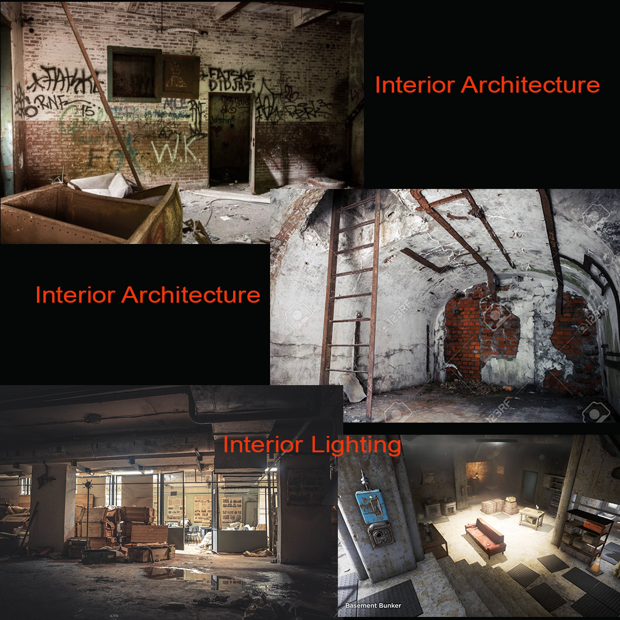
Figure 6: Contact Sheet for Visual Theme 1 [#]

Visual Theme 2 for New Broken Hills

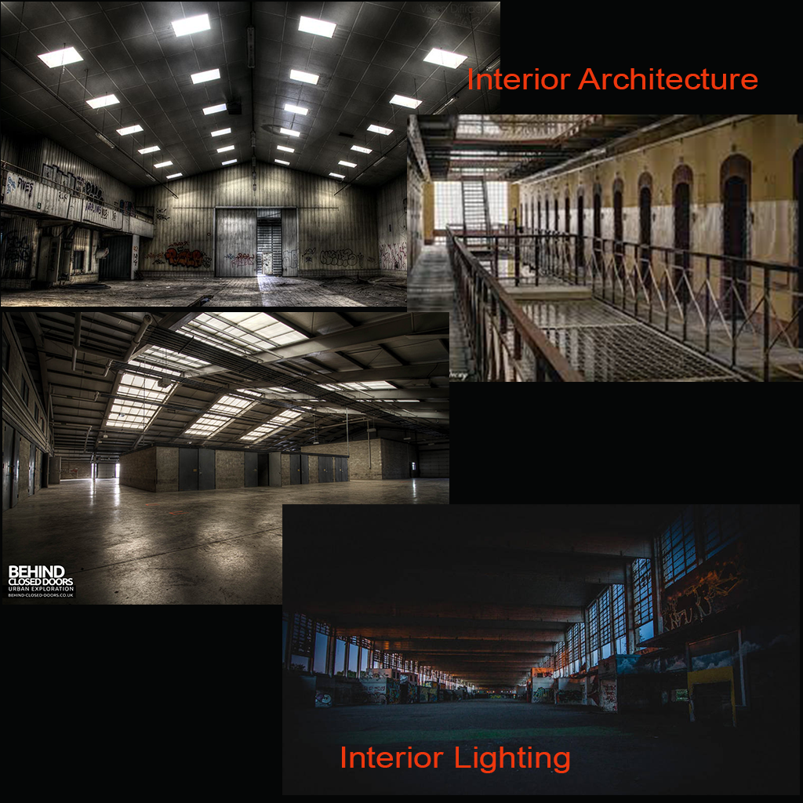
Figure 7: Contact Sheet for Visual Theme 2 [#]

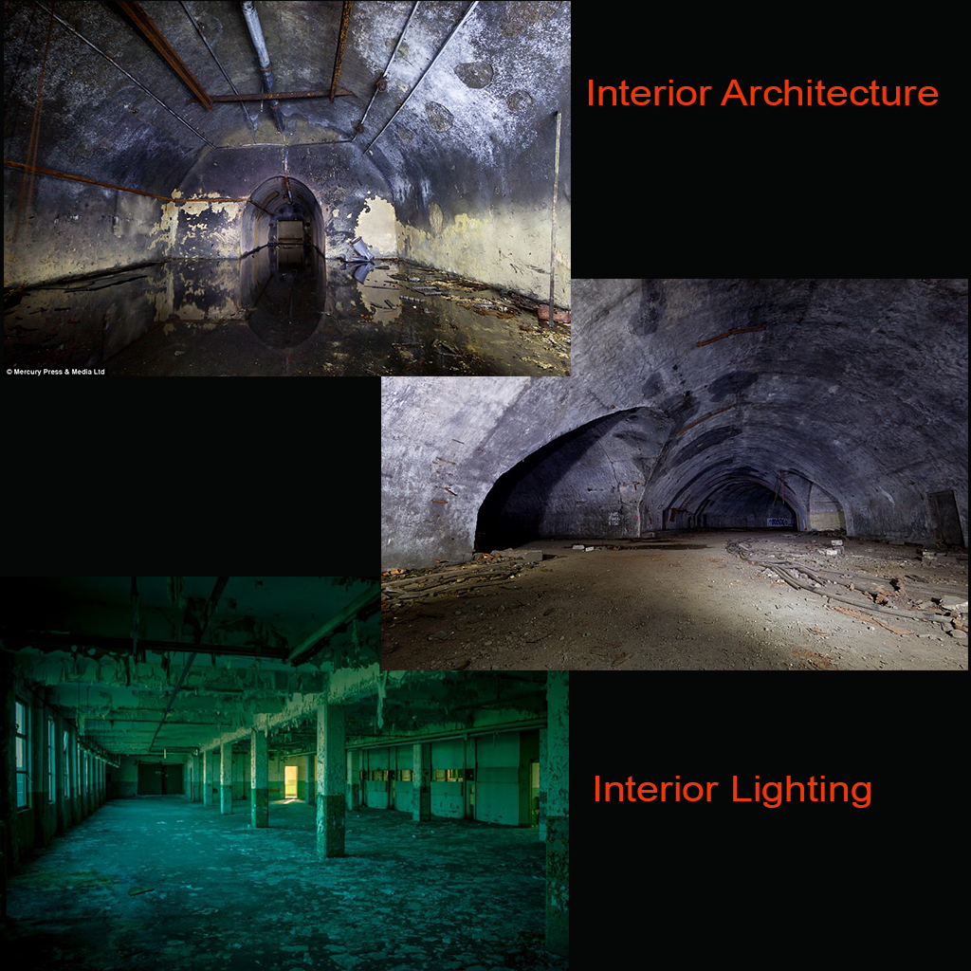
Visual Theme 3 (replace with meaningful name of theme)>

Figure 8: Contact Sheet for Visual Theme 3 [#]

Requirements
Map Label | Description | Type | Priority
1-2 | Scripted Event where the player encounters NPC fighting Ghouls, the NPC greets the player then proceeds to the bunker he was trying to secure. (Solution: move Cohen to caravan shack and make him sit until it’s time for him to teleport. | Event | High
3-8 | Trigger that turns settlement faction hostile if the player attacks any of the settlement members at any point. | Scripting | Medium
2-7 | Scripts to have all NPC’s sleep at a specific time. | NPC pathing | Low
3-4 | Supermutant NPC’s pace back and forth on the upper level beyond the stairs.. | NPC pathing | Low
3-4 | NPC’s interact with various stations within the settlement occasionally. | NPC pathing | Medium
7 | Event that shows Grem running away to inform Sidney and the settlement of the players actions once they return to the upper level of the settlement. | Scripting | Low
3-8 | Consequences for attacking settlement | Scripting | High
9 | Trigger to turn the Paladin hostile if you choose to keep the nuclear materials. | Scripting | High

Appendix A: Quest Summary
Quest stages

Main Quest
- The Player starts at Ranger Cabin just across the visible distance in the hills of the Commonwealth. Gunshots are heard in the players direction ahead. The player should proceed to the opened gates of Wicked Shipping Fleet Lockup and hear louder gunshots with a man fighting ghouls.
- The player will proceed to help the NPC Paladin Cohen fight 4 Ghouls throughout the lot. After fighting off the ghouls the player will meet Paladin Cohen who greets you and proceeds into the bunker he was attempting to secure. After following the Paladin, you discover he’s apart of the Brotherhood of Steel, then he asks of your help for the cause of the Brotherhood. The player can reject but the quest can’t be started until the player accepts the quest. Paladin Cohen will inform the player that there is a bunker in the Robotics Disposal Ground that has human’s hostage. He wants you to go kill the mutants, free the captives and retrieve the suppose nuclear materials they have.
- After receiving the quest, the player will travel to the east to a nearby bunker entrance at the Robotics Disposal Ground to a settlement where the player will enter to carry out the quest.
- Upon entering the bunker, the player will greet a woman by the name of Sidney Graham. She welcomes you to the settlement to which she informs you of their coexistence with Supermutants. The player will meet human NPC’s Stallin, and Conner and also Supermutant guard watch Grem, Gram and Grout. The player can choose to kill all the Supermutant’s and proceed toward the underground layer if they choose to carry out Paladin’s request.
- After exploring the settlement, the location of nuclear materials become revealed in the bunker entrance just north of the settlement. It’s guarded by a Supermutant named Grem that the player can speak to.
- After entering the underground mutant’s layer, the player will fight past seven radroaches. The Supermutant’s resting post has a couple of mini nukes and a fatboy the player can grab to fight off the combat the player will have the choice of making in the future.
- In the dead-end of the south side of the cell, the player will encounter a Supermutant by the name of Grool. He apologizes for the mess and ask the player what they need. In this stage the player can choose to tell Grool to move out of the way in an attempt to take the nuclear materials and engage in combat. If the player hasn’t already fought the settlers in the upper layer, he will have to on the way out as a result of killing Grool. If Grem is still alive in the attack of Grool he runs and informs Sidney and all the Settlers of the players actions. Also, the player can inform Grool of the Brotherhood of Steel’s awareness of the settlement, and suggest everyone relocate. Grool will offer to give the player a fake nuclear canister to return to Cohen to “satisfy” the Brotherhood’ technological request at the least in an attempt to fool the Paladin.

Critical Dialogue

Paladin Cohen
Greet/Quest Acceptance: Thanks for your help back there civilian, I greatly appreciate it. I’m Paladin Cohen, would you be willing to contribute to the Brotherhood’s cause? I’ve lost my men to Supermutants from the Northside.
- Players Response: Yes, what do you need?
  - No, I’ll pass. I don’t believe in your cause and I’ve helped you enough.
Cohen’s Response: I appreciate your participation civilian. There’s a bunker in the east just nearby the Robotics Disposal Ground. Human’s are being held captive by Supermutants that have access to nuclear materials. Take care of those disgusting mutants, recover the nuclear tech and bring it back to me and I should have something for you. [Quest Accepted] [End]
- Cohen:
  - No: I understand and you saved my life, so you owe the Brotherhood nothing
Sidney
Greet/Information: Hello stranger, welcome to our settlement, my name is Sidney Graham. Here we coexist with Supermutants. As crazy is the world is these days, we seek protection and peace. We have food, technology and comfort in our settlement and I couldn’t ask for anything more.
- Players Response Positive: That’s really great, I never knew such a thing could exist. I’ll have a chat with some settlers
  - Negative: I don’t care about your settlement, I’m here for the nuclear materials and to kill all these mutants. Out of my way. [End] [Hostile]
Grool
Greet/Decision
Greet/Information: How goes? The name’s Grool. Apologize for the mess and all the roaches. Can I help you with something?
- Players Response: I think you should know that the Brotherhood knows you guys are here and I suggest you all migrate elsewhere before they send reinforcements
  - Negative: I want what’s behind you, out of my way! [End]
Grool’s Response: Can’t seem to call any place home anymore I guess. Least I can do in spite of those fools is give you this canister of my piss to return to the Paladin. Help yourself to the mini nuke and missles in my room if you like.
Cohen
Quest Completion/Failure
Greet: What’s the word civilian, you got that nuclear technology? Any dead muties?
- Players Response Complete: Yea, here you go. Was a hell of a lot of trouble
  - Failure: I’m ganna keep it actually, sorry.
Cohen’s Complete: I’m sure, here’s your reward as promised. Thanks for contributing to the Brotherhood’s cause. [End]
- Failure: Well if you won’t give it to me, I’ll just have to take it then! [End] [Hostile]

References
- https://fallout.fandom.com/wiki/Broken_Hills
- https://www.google.com/search?q=interior+lighting+abandoned+hangar&rlz=1C1CHBF_enUS810US810&source=lnms&tbm=isch&sa=X&ved=0ahUKEwintLuqrfXgAhVh64MKHcNZDvAQ_AUIDigB&biw=1280&bih=646&dpr=1.5#imgrc=GxzSRvuipb6WRM:
- https://www.google.com/search?rlz=1C1CHBF_enUS810US810&biw=1280&bih=613&tbm=isch&sa=1&ei=-diDXMGaAaa3jwSU0r3YBA&q=interior+lighting+abandoned+hangar+staits&oq=interior+lighting+abandoned+hangar+staits&gs_l=img.3...147051.150651..150783...4.0..0.92.971.11......1....1..gws-wiz-img.uddkpx5OU1I#imgdii=5YrLGt0RAP3yfM:&imgrc=_EyTk-Nj96h6FM:
- https://www.google.com/search?rlz=1C1CHBF_enUS810US810&biw=1280&bih=613&tbm=isch&sa=1&ei=kNmDXPj6JcSYjwSXr6T4DA&q=interior+lighting+abandoned+hangar&oq=interior+lighting+abandoned+hangar&gs_l=img.3..35i39l2.51799.51930..52173...0.0..0.96.181.2......1....1..gws-wiz-img.RG5JdcZA_go#imgrc=BvKUNNTXGpxdjM:
- https://www.google.com/search?rlz=1C1CHBF_enUS810US810&biw=1280&bih=613&tbm=isch&sa=1&ei=xdmDXIqIL4vKjgSgs7WwCw&q=abandoned+undergriundhangar&oq=abandoned+undergriundhangar&gs_l=img.3...144957.149214..149360...1.0..0.103.1169.11j2......1....1..gws-wiz-img.......0j0i8i30j0i24.PqiT2R8aQAE#imgrc=wx0y9JTvnyH7JM:
- https://www.google.com/search?rlz=1C1CHBF_enUS810US810&biw=1280&bih=613&tbm=isch&sa=1&ei=xdmDXIqIL4vKjgSgs7WwCw&q=abandoned+undergriundhangar&oq=abandoned+undergriundhangar&gs_l=img.3...144957.149214..149360...1.0..0.103.1169.11j2......1....1..gws-wiz-img.......0j0i8i30j0i24.PqiT2R8aQAE#imgdii=h0c1aC2_HGSC9M:&imgrc=wx0y9JTvnyH7JM:
- https://www.google.com/search?rlz=1C1CHBF_enUS810US810&biw=1280&bih=613&tbm=isch&sa=1&ei=cNuDXJGlG5DUsAWxuqO4DQ&q=abandoned+hangar&oq=abandoned+hangar&gs_l=img.3..0j0i8i30l3j0i24.1066.22290..22575...0.0..0.89.176.2......1....1..gws-wiz-img.98emsYfZkGg#imgrc=DGCgYdMruMvG4M:
- https://www.google.com/search?rlz=1C1CHBF_enUS810US810&biw=1280&bih=613&tbm=isch&sa=1&ei=wuCDXPeUI6S0jwTopKzwBA&q=abandoned+bunker&oq=abandoned+bunker&gs_l=img.3..0l4j0i8i30l6.64407.65082..65365...0.0..0.102.481.2j3......1....1..gws-wiz-img.......0i67j0i30.rjCZFyZd7ng#imgrc=BSMfDFZFrjbjXM:

